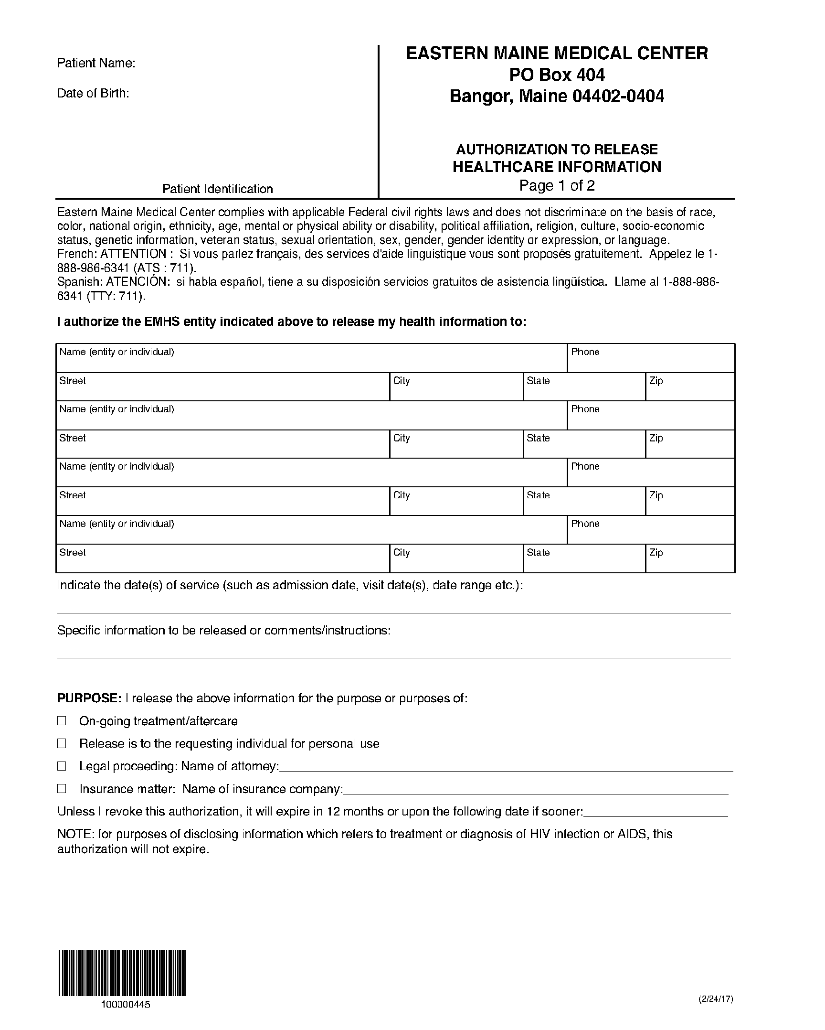
Batman
01/01/1979
Axiom Requisition Copy Service
2869 Jolly Road
(877) 886-5090
Okemos
MI
48864

John Doe, Smith and Jones PC
✓

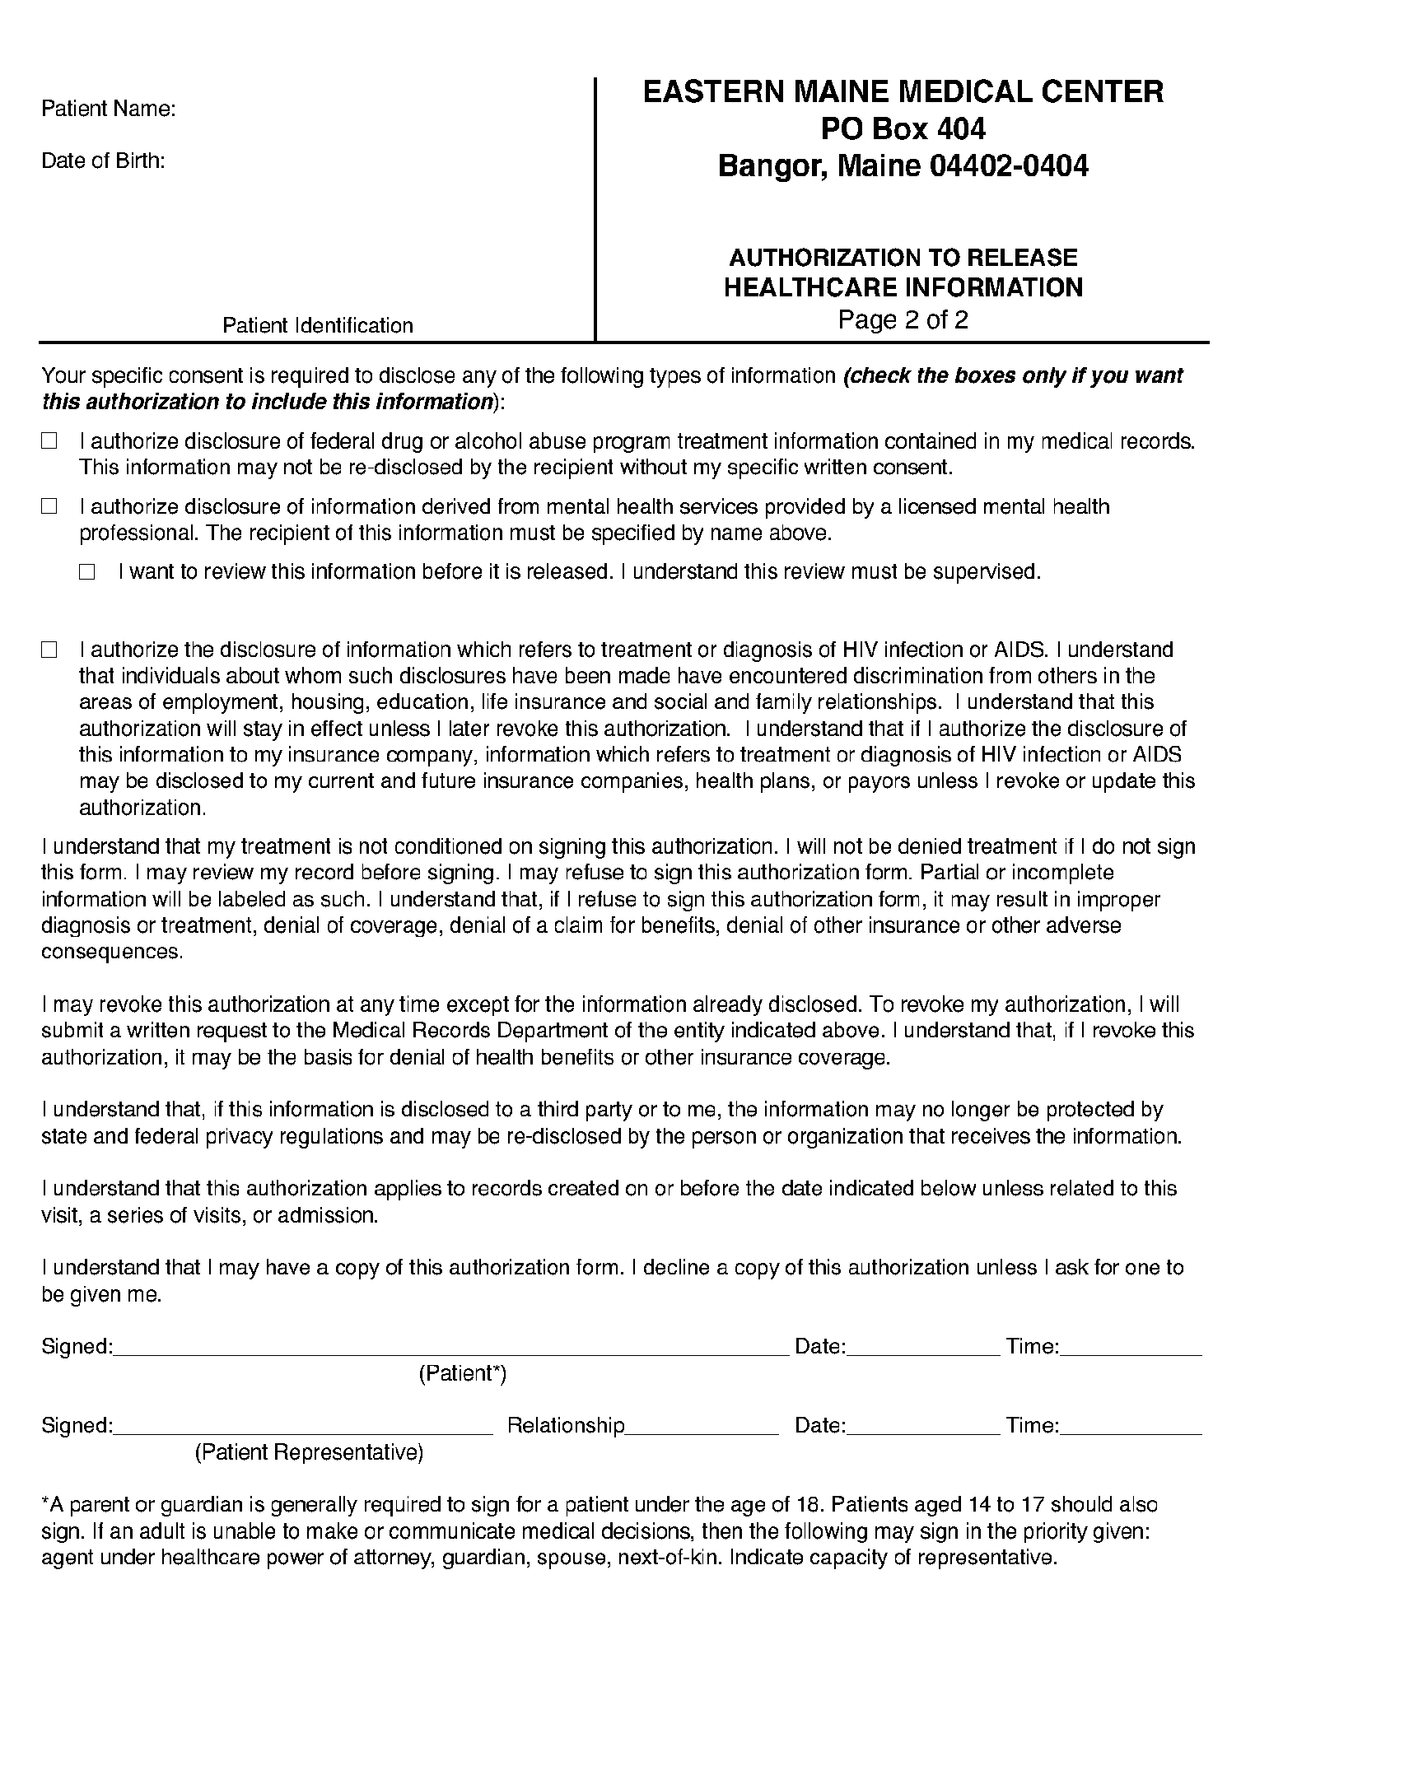
Batman
01/01/1979
✓

✓

✓

